CROSS ROADS DENTAL
MANUAL
in terms of
The Promotion of Access to Information Act 2 of 2000
and
The Protection of Personal Information Act 4 of 2013
2020

INDEX
- Introduction
- Company contact details
- The South African Human Rights Commission
- Applicable legislation
- Schedule of records
- Requesting information not publicly available
- Grounds for refusal of access to certain records
- Decision to grant or deny access
- Remedies for refusal of access to information request
- Fees
- Protection and processing of personal information in line with POPIA

NOTICE: PLEASE READ THIS MANUAL CAREFULLY BEFORE REQUESTING INFORMATION FROM US. NO INFORMATION WILL BE PROVIDED IF THE REQUIREMENTS AND PROCESSES SET OUT HEREIN ARE NOT ADHERED TO

INTRODUCTION

Thank you for reading this manual, which we make available to you in accordance with section 51 of Promotion of Access to Information Act 2 of 2000, as amended from time to time (“PAIA”) and regulation 4(1)(d) of the Protection of Personal Information Act 4 of 2013 (“POPIA”) Regulations (the/this “Manual”).

A copy of this manual is available at -
    - our website: https://crdental.co.za/
    - our office, as detailed in paragraph 2.1 below, and you will be required to give us at least 7 (SEVEN) days prior written notice of your intention to come in and view this; and
    - the offices of the Commission, as described in paragraph 3.2 below.

A copy of this Manual may be requested and obtained from our Deputy Information Officer in writing and at a prescribed fee.

Company details: We are Dr Engelbrecht & Dr Van Heerden Inc, registration number: 2018/225438/21, a company incorporated in accordance with the company laws of the Republic of South Africa, (“we” / “us”).

This Manual contains the procedures and relevant legislative provisions applicable to all access to information requests submitted to us.

Prior to any access to information requests being granted, the requester (any person, including, but not limited to, a public body or an official thereof, making a request for access to a record of that private body; and includes a person acting on behalf of such a person) must comply with all relevant requirements in PAIA and to the extent applicable, POPIA (the “Requester”).

COMPANY DETAILS

Company Contact Details
Company Name: DR ENGELBRECHT & DR VAN HEERDEN INC
Head of Company: LIANA VAN HEERDEN
Postal Address: P.O. BOX 12085, NELSPRUIT, 1200
Street Address: 2 DIRKY UYS STREET, NELSPRUIT, MPUMALANGA, 1200
Telephone Number: 087 150 2657
Email: admin@crdental.co.za
Website: https://crdental.co.za/

Company Information Officer Details
Name of Information Officer: LIANA VAN HEERDEN
Postal Address: P.O. BOX 12085, NELSPRUIT, 1200
Street Address: 2 DIRKY UYS STREET, NELSPRUIT, MPUMALANGA, 1200
Telephone Number: 087 150 2657
Email: liana@crdental.co.za

THE SOUTH AFRICAN HUMAN RIGHTS COMMISSION

The South African Human Rights Commission (the “Commission”) has compiled a guide in terms of section 10 of the South African Human Rights Commission Act 40 of 2013 (the “Act”). This guide contains information which will assist any person who wishes to exercise any of their rights in terms of the Act and PAIA.

The contact details of the Commission are as follows:
Postal Address: Private Bag 2700, Houghton, 2041
Telephone Number: (+27)11 877 3600
Fax Number: (+27)11 403 0625
Website: www.sahrc.org.za

APPLICABLE LEGISLATION

In compliance with section 51(1)(c) of PAIA, a list of legislation applicable to us is attached as Annexure A hereto.

SCHEDULE OF RECORDS

In compliance with section 51(1)(d) of PAIA, a list of records kept by us is attached as Annexure B hereto.

Kindly note that the table in Annexure B indicates the availability of such records, these may either be available freely to the public or will be made available the Requester, subject to a successful request in terms of the relevant PAIA or POPIA sections.

REQUESTING ACCESS TO INFORMATION NOT PUBLICLY AVAILABLE

The Requester must comply with the following when submitting a request for information that is not generally available to the public:

All the procedural requirements as set out in section 53 of PAIA.

Complete and submit the prescribed Request for Access form, attached as Annexure C hereto. This form should be accompanied by payment of a request fee (if applicable) and a deposit (if applicable). Submission must be made to the Information Officer as set out in clause 2.2 above.

Provide sufficient details to enable us to identify the -
    - requested record(s);
    - Requester (and proof of capacity to request the record(s) on behalf of someone else);
    - postal address or fax number of the Requester in the Republic;
    - right which the requester is seeking to exercise or protect with an explanation of the reason the record is required to exercise or protect the right.

If the Requester wishes to be informed of the decision in any manner (in addition to written) the manner and particulars thereof should also be provided to us.

GROUNDS FOR REFUSAL OF ACCESS TO CERTAIN RECORDS

In terms of Part 3, Chapter 4 of PAIA there are a number of grounds that warrant the refusal to release certain records. Such instances include mandatory protection of -
    - privacy of a third party who is natural person;
    - commercial information of a third party;
    - certain confidential information of a third party;
    - information relating to the safety of individuals, and protection of property;
    - records privileged from production in legal proceedings;
    - commercial information of a private body; and
    - research information of third parties, and protection of research information of private bodies.

Requests for records which are clearly frivolous, vexatious or involve an unreasonable diversion of resources may also be refused.

DECISION TO GRANT OR DENY ACCESS

Our Information Officer will deliberate and decide on the request of the Requester within 30 (THIRTY) days of receipt of the request for access.

In cases where the request for access is for a large number of records or the request requires a search at more than one of our offices the period may be extended for a further period of up to 30 (THIRTY) days.

The company will make use of the information provided in Annexure C hereto to inform the relevant Requester of such an extension in writing.

REMEDIES FOR REFUSAL OF ACCESS TO INFORMATION REQUEST

Internal Appeal

The decision of the Information Officer or Deputy Information Officer is final in terms of our internal procedures for access to information. The external remedies set out below remain available to the Requester, however there is no internal appeal procedure.

External Appeal

The Requester may in terms of sections 56(3)(c) and 78 of PAIA apply to a court within 180 days of notification of the decision for appropriate relief.

FEES

Request Fee

The Request Fee is a standard fee, which is payable before the request of the Requester will be processed.

Deposit

In the event that the preparation of the records requested exceed 6 (SIX) hours, a deposit is payable equal to not more than one third of the access fees (which would be payable if the request were to be granted).

Payment of fees

Records successfully requested will only be released to the Requester once all fees have been paid in full.

Fee structure

The fee structure is available on the website of the Commission at: www.sahrc.org.za.

PROTECTION AND PROCESSING OF PERSONAL INFORMATION IN LINE WITH POPIA

Please take note that this Manual is subject to and should be read with our Privacy Policy.

We respect your right to privacy, as contained in section 14 of the Constitution of the Republic of South Africa of 1996, and which forms the cornerstone of POPIA. In order for us to assist you, it may be necessary for you to share some of your Personal Information with us from time to time.

We will take all reasonable steps to protect the Personal Information of any Data Subjects which is in our possession. For the purposes of this section, “Data Subject”, “Personal Information”, “Processing” and “Responsible Party” will be understood in accordance with the definition provided in POPIA. Any such Personal Information that you may share with us, and the reasons why such information is required, will depend on the nature and scope of your relationship with us.

We attach as Annexure D hereto the types of Personal Information we Process as well as the purpose for which such Personal Information is Processed.

As a Responsible Party, we undertake to comply with the relevant provisions of POPIA in relation to the Processing of Personal Information.

In particular, we undertake and are committed to comply with the 8 (EIGHT) conditions for the lawful Processing of Personal Information contained in Chapter 3 of POPIA, as set out below:
    - Accountability.
    - Processing limitation.
    - Purpose specification.
    - Further processing limitation.
    - Information quality.
    - Openness.
    - Security safeguards.
    - Data subject participation.

Personal Information will be Processed by us, our representatives, our affiliates and their representatives.

Should the cross-border flow of Personal Information be necessary in the course of business and the purpose for which the Personal Information is Processed, it will only take place if all the conditions as set out in section 72 of POPIA are complied with.

We attach as Annexure E hereto a description of the security measures to be implemented to ensure protection of Personal Information.

Should any Data Subject object to the Processing of their Personal Information, they may lodge such objection by completing the form attached as Annexure F hereto and email the completed form to: liana@crdental.co.za

Should any Data Subject wish to request that we destroy Personal Information in our possession, they may complete the form attached as Annexure G hereto and email the completed form to: liana@crdental.co.za .In the event that such a request is lodged, Data Subjects should take note of the fact that we may not be able to continue our relationship with you if we cannot Process your Personal Information. Of course, should any law require us to not destroy your Personal Information, a request of this nature cannot be complied with.

We have a comprehensive data management framework in place in order to comply with POPIA and ensure that the best efforts are employed to ensure the protection of Personal Information Processed by us. We employ up to date technology to ensure the confidentiality, integrity and availability of the Personal Information under our care.

ANNEXURE A: LEGISLATION APPLICABLE TO THE COMPANY
The Companies Act 71 of 2008
Basic Conditions of Employment Act 75 of 1997
Broad Based Black Economic Empowerment Act 53 of 2003
Compensation for Occupational Injuries and Diseases Act 130 of 1993
Consumer Protection Act 68 of 2008
Electronic Communications and Transactions Act 25 of 2002
Employment Equity Act 55 of 1998
Income Tax Act 95 of 1967
Labour Relations Act 66 of 1995
Promotion of Access of Information Act 2 of 2000
Protection of Personal Information Act 4 of 2013
Unemployment Insurance Act 30 of 1996

ANNEXURE B: RECORDS
The inclusion of any subject or category of records should not be taken as an indication that records falling within those subjects and/or categories will be made available under PAIA. In particular, certain grounds of refusal as set out in PAIA may be applicable to a request for such records.
The following categories of records are held by us:
- Statutory company information.
- Financial and tax records.
- Banking details.
- Human resources / Employment records.
- Specific agreements relating to our business activities.
- Policy documents.
- Miscellaneous agreements.
- Internal and external correspondence.
- Records pertaining to our clients/customers.

ANNEXURE C
FORM C
REQUEST FOR ACCESS TO RECORD OF PRIVATE BODY
(Section 53(1) of the Promotion of Access to Information Act, 2000 (Act No. 2 of 2000)) [Regulation 10]

A. Particulars of private body
The Head:
LIANA VAN HEERDEN
B. Particulars of person requesting access to the record
(a) The particulars of the person who requests access to the record must be given below.
(b) The address and/or fax number in the Republic to which the information is to be sent must be given.
(c) Proof of the capacity in which the request is made, if applicable, must be attached.

Full names and surname: ……………………………………………………………………………………. Identity number:…………………………………………………………………………………………………… Postal address: ………………………………………………………………………………………………… Telephone number: (………) …………………………… Fax number: (………)……………………….….. E-mail address: ………………………………………………………………………………………………… Capacity in which request is made, when made on behalf of another person:
………………………………………………………………………………………………………………………
C. Particulars of person on whose behalf request is made
This section must be completed ONLY if a request for information is made on behalf of another person.

Full names and surname: ……………………………………………………………………………………… Identity number: …………………………………………………………………………………………………..
D. Particulars of record
(a) Provide full particulars of the record to which access is requested, including the reference number if that is known to you, to enable the record to be located.
(b) If the provided space is inadequate, please continue on a separate folio and attach it to this form. The requester must sign all the additional folios.

1. Description of record or relevant part of the record:
………………………………………………………………………………………………………………………………………………………………………………………………………………………………………………………………………………………………………………………………………………………………………………………………………………………………………………………………………………………………
2. Reference number, if available:
………………………………………………………………………………………………………………………………………………………………………………………………………………………………………………………………………………………………………………………………………………………………………………………………………………………………………………………………………………………………
3. Any further particulars of record:
………………………………………………………………………………………………………………………………………………………………………………………………………………………………………………………………………………………………………………………………………………………………………………………………………………………………………………………………………………………………
E. Fees
(a) A request for access to a record, other than a record containing personal information about yourself, will be processed only after a request fee has been paid.
(b) You will be notified of the amount required to be paid as the request fee.
(c) The fee payable for access to a record depends on the form in which access is required and the reasonable time required to search for and prepare a record.
(d) If you qualify for exemption of the payment of any fee, please state the reason for exemption.

Reason for exemption from payment of fees:
………………………………………………………………………………………………………………………………………………………………………………………………………………………………………………………………………………………………………………………………………………………………………………………………………………………………………………………………………………………………
F. Form of access to record
If you are prevented by a disability to read, view or listen to the record in the form of access provided for in 1 to 4 below, state your disability and indicate in which form the record is required.
Disability:…………………………………..… | Form in which record is required:……………………………..
Mark the appropriate box with an X.
NOTES:
- Compliance with your request for access in the specified form may depend on the form in which the record is available.
- Access in the form requested may be refused in certain circumstances. In such a case you will be informed if access will be granted in another form.
- The fee payable for access to the record, if any, will be determined partly by the form in which access is requested.

 | 1. If the record is in written or printed form:
 |  | copy of record* |  | inspection of record
2. If record consists of visual images -
(this includes photographs, slides, video recordings, computer-generated images, sketches, etc.):
 |  | view the images |  | copy of the images* |  | transcription of the images
 | 3. If record consists of recorded words or information which can be reproduced in sound:
 |  | listen to the soundtrack (audio cassette) |  | transcription of soundtrack* (written or printed document)
 | 4. If record is held on computer or in an electronic or machine-readable form:
 |  | printed copy of record* |  | printed copy of information derived from the record* |  | copy in computer readable form*  (stiffy or compact disc)
*If you requested a copy or transcription of a record (above), do you wish the copy or transcription to be posted to you?  Postage is payable. |  |  |  |  |  |  | YES | NO

G. Particulars of right to be exercised or protected
If the provided space is inadequate, please continue on a separate folio and attach it to this form.
The requester must sign all the additional folios.

Indicate which right is to be exercised or protected:
……………………………………………………………………………………………………………………………………………..……………………………………………………………………………………………………………………………………………..………………………………………………………………………
Explain why the record requested is required for the exercise or protection of the aforementioned right:

……………………………………………………………………………………………………………………………………………..……………………………………………………………………………………………………………………………………………..………………………………………………………………………
H. Notice of decision regarding request for access
You will be notified in writing whether your request has been approved / denied. If you wish to be informed in another manner, please specify the manner and provide the necessary particulars to enable compliance with your request.
How would you prefer to be informed of the decision regarding your request for access to the record?
………………………………………………………………………………………………………………………

Signed at …………………………….…………. this day………… of ……………..……………year ……….

………………………………………………………………
SIGNATURE OF REQUESTER /
PERSON ON WHOSE BEHALF REQUEST IS MADE

ANNEXURE D

DATA SUBJECTS | PERSONAL INFORMATION PROCESSED
Customers:  Corporate Customers  Individual Customers | Various categories of general and special Personal Information, as the context and relevant circumstances may require.  Various categories of general and special Personal Information, as the context and relevant circumstances may require.
Suppliers: | Various categories of general and special Personal Information, as the context and relevant circumstances may require.
Personnel: | Various categories of general and special Personal Information, as the context and relevant circumstances may require.

ANNEXURE E: SECURITY MEASURES

We undertake to put in place, monitor and maintain reasonable technical (electronic) and organizational (physical) security measures in order to safeguard all Personal Information Processed by us and to ensure the integrity and confidentiality of such information.

ANNEXURE F
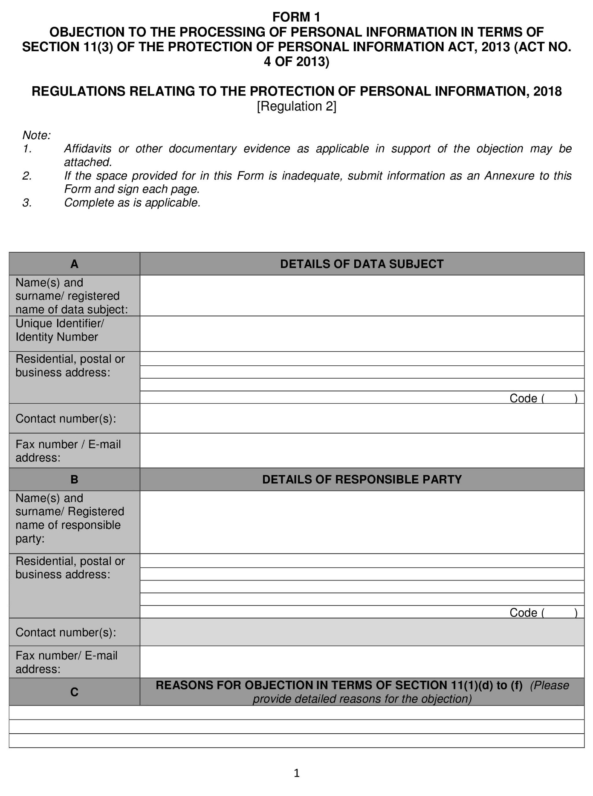

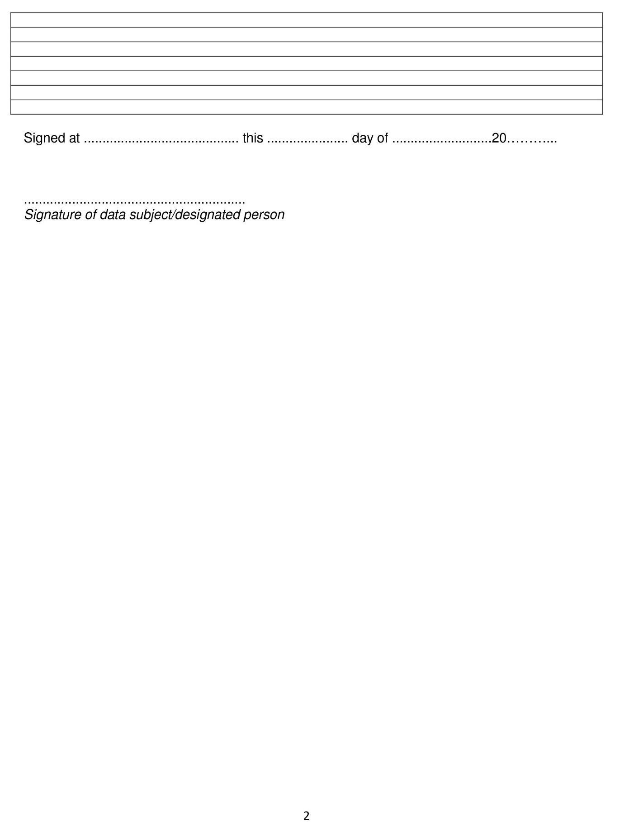

ANNEXURE G
